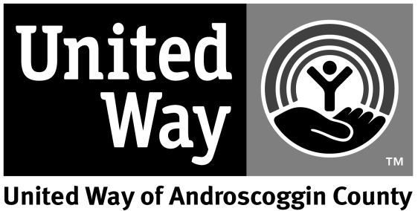
PHASE 34 EMERGENCY FOOD

AND SHELTER PROGRAM

Androscoggin County EFSP Funding Request Instructions

Following is the Phase 34 Emergency Food & Shelter Program Application. Please note the following:
- With Phase 33, per meal allowance remains $2.00. Mass shelters must decide on either $7.50 or $12.50 to supplement their services. Whichever rate the LRO (local recipient organization) decides to use for mass shelters must be determined at the beginning of the program and maintained until the end of the spending period.
- Transportation costs may only be reimbursed using a dated mileage log at the current federal rate, which is $.53.5.
- In addition to the funding application, please submit current year agency and program budget with year-to-date figures, along with Funding Sources Grid provided with application.
- Agencies can to apply to any of the following program categories: Food, Utility Assistance, Mass Shelter, Other Shelter, Served Meals, Supplies/Equipment, Rent/Mortgage Assistance.
- Agencies receiving awards in Phase 32 will be required to submit all appropriate certification forms to complete application process. Certification forms will be available on the National EFSP website.
- One (1) hard copy and one (1) electronic copy must be submitted by the deadline. Electronic copies may be emailed to: kpreble@unitedwayandro.org.
Application deadline is November 30, 2017 by 3:00 PM. NO EXCEPTIONS OR EXTENSIONS WILL BE GRANTED. All applicants should submit one (1) electronic copy and one (1) hard copy by the application deadline. Hard copies can either be dropped off at the United Way office or mailed to this address:

Kim Preble
Director of Community Engagement
United Way of Androscoggin County
PO Box 888
Lewiston, ME 04243
kpreble@unitedwayandro.org

No faxed copies will be accepted. The total amount of funds to be awarded through the local board for Phase 34 is $36,180. Please call (795.4000) or e-mail (kpreble@unitedwayandro.org) if you need clarification or have questions.

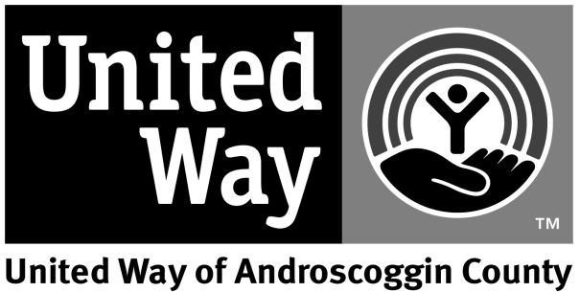

PHASE 34 EMERGENCY FOOD
AND SHELTER PROGRAM

Androscoggin County
EFSP Funding Request Application

Cover Sheet

Agency:

Executive Director:

Contact Person(if different from above):

Physical Address:

Mailing Address:

Telephone:

Fax:

E-mail:

FEIN#:

DUNS#:

Program Category:

Amount Requested:

Proposal

Clearly identify each of the following eight parts in your submitted proposal. Application should be limited to 3 pages, all responses should be typed in size 12 Times New Roman font.

PART I: Define the problem. What is the nature of the problem that you are trying to address? Who is experiencing the problem? Where does the target population live? Consider the target population in the community and the program’s client population.

PART II: Goals - What effect will this program have on the problem?

PART III: Outcomes – Outcome objectives describe the effects that the program is trying to produce on the client: i.e. changes in client’s knowledge, skills, attitude, behavior or condition.

PART IV: Services – What is the service that the agency is requesting funding for? Who provides it? Where is it available? When is it available? How is it delivered? How do you define units of service? What is the cost per unit of service? How do you determine the cost per unit?

PART V: Outreach – How do you publicize the program within the community? Who does the agency partner with & how does agency avoid duplication of services?

PART VI: Organization – Describe your agency’s strategy providing proposed services?

PART VII: History – How was funding used last year if agency was a recipient? Was funding sufficient to meet identified needs? If not, please explain and provide the number of individuals who were unserved because of insufficient resources. Provide end-of-year duplicate and unduplicated numbers served. Please provide information that you would want to see if you were the decision maker.

PART VIII: Other Funding Sources – How does your agency program leverage other sources of funding with EFSP grant money? All applicant agencies must complete following Funding Sources Grid whether or not your agency leverages other sources:

United Way or Similar $_________________
Individuals $_________________
Corporations/Foundations $_________________
Government Agencies (Fed, State, Local) $_________________
In-Kind $_________________
Requested EFSP Funds $_________________

TOTAL $_________________

As a Local Recipient Organization (LRO) thus agency agrees to abide by all national and local program requirements

Signature______________________________________________________________
_{Executive Director}

Date________________________________

Critical Criteria Checklist

To assist you in ensuring that your Phase 34 EFSP Funding Request Application is complete and will receive full consideration, please use the following checklist and submit, with appropriate signature, with your Funding Request Application. Indicate with a check (√) for those Funding Request Application elements which are enclosed.

Proposal Narrative:
_____Completed Cover Sheet.
_____(I) Define the Problem.
_____(II) Goals.
_____(III) Outcomes.
_____(IV) Services.
_____(V) Outreach.
_____(VI) Organization.
_____(VII) History.
_____(VIII) Other Funding Sources.
_____Executive Director Signature and Date

Budget Information:
_____Current Year Agency and Program Budget w/Year-To-Date Figures.

If any of the above funding request elements are missing or incomplete, please attached a written explanation.

The above critical elements checked are complete and included in

_______________________________________ Funding Request Application.
Name of Agency

__________________________________________
Signature/Title of Person Submitting Funding Request Package

_____________
Date

